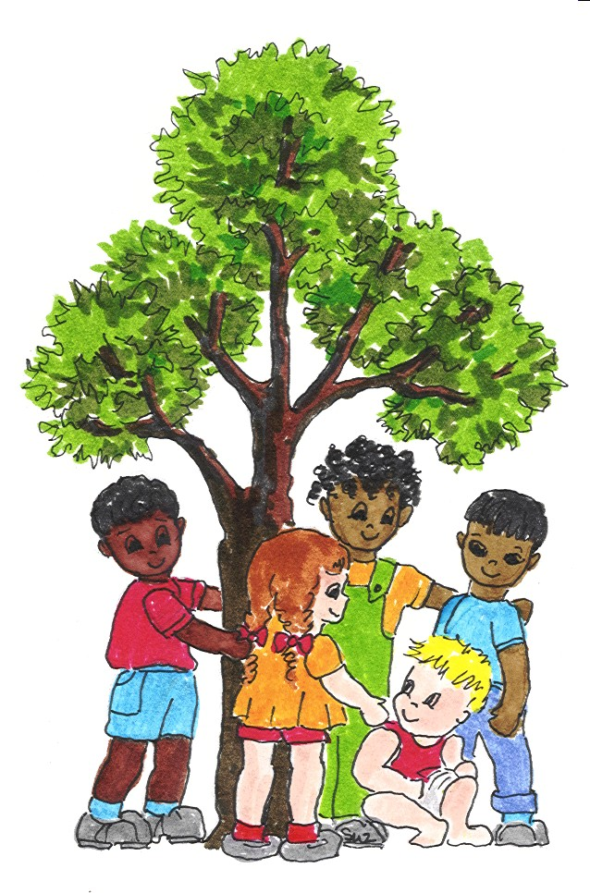Arizona State University Infant Child Research Programs

200 E. Curry Rd. Suite 146 (480) 965-9396
P.O. Box 871908 Fax: (480) 965-0965

Tempe, AZ 85287-1908 http://icrp.asu.edu

ALL ABOUT ME

Form Completed By: Date Completed:
Relationship to Child:

MY FAMILY
Child’s Name: Nickname:
Mother’s Name: Father’s Name
Address:

Phone Number: E-mail

Date of Birth: Chronological Age: Gender: Male Female

Please list all family members or other persons who live in the home and/or contribute to the child’s care.

Name: Relationship to child:
Home Address: Home Phone #:
E-mail: Place of Employment:
Work Phone #: Lives with Child: Yes No

Name: Relationship to child:
Home Address: Home Phone #:
E-mail: Place of Employment:
Work Phone #: Lives with Child: Yes No

Name: Relationship to child:
Home Address: Home Phone #:
E-mail: Place of Employment:
Work Phone #: Lives with Child: Yes No

Name: Relationship to child:
Home Address: Home Phone #:
E-mail: Place of Employment:
Work Phone #: Lives with Child: Yes No

Child’s Racial/Ethnic Background:
African-American Asian Pacific Caucasian Hispanic (not Black)
Native American Biracial Other

Referred By:
Pediatrician Developmental Pediatrician Speech-Language Pathologist

Occupational Therapist Physical Therapist Psychologist School

Family Member/Friend Word of Mouth Other

Please describe the concerns regarding your child’s development:

How long have you been concerned?

Has your child been diagnosed with any of the following conditions? Check all that apply.
ADHD Yes No
Articulation/phonology Yes No
Autism spectrum disorder Yes No
(PDD, autism, aspergers)
Behavior problems Yes No
Genetic disorder Yes No
Hearing disorder Yes No
Expressive and/or receptive language disorder Yes No
Learning problem Yes No
Oral motor feeding Yes No
Sensory integration difficulties Yes No
Stuttering Yes No
Other

If yes, please describe the nature of the diagnosis, and by whom & when it was made:

DEVELOPMENTAL HISTORY

Before I Was Born

My mother had the following health problems during the pregnancy (please describe)

My mother was exposed to drugs (over the counter or illicit), alcohol, x-ray treatments, or had an accident during the pregnancy (please describe):

My mother was exposed to an infectious disease or other illness during the pregnancy (please describe):

My Arrival

When I was born, I weighed:

My mother carried me to term: Yes No

No, I was in a hurry and was born weeks early!

My birth presentation was: vaginal C-section

Let me tell you what happened:

I was in the Neonatal Intensive Care Unit (NICU) for:

I had these challenges at or immediately after my birth:

Condition | Present? | Condition | Present?
Breathing difficulties  Required Oxygen  Jaundice  Infections (e.g., meningitis)  Cleft lip/palate | Y N  Y N Y N  Y N  Y N | Seizures  Physical abnormalities  Paralysis  Medications | Y N  Y N  Y N  Y N
Let me tell you about other difficulties, concerns, conditions, or treatment I experienced during the birth process (please describe):

My General Health after Birth:

I had the following illnesses or diseases (check all that apply):

Ear Infections: Rarely Occasionally Frequently Constantly

Age range of occurrence:

Most recent episode: Infections resolve quickly? Yes No

Typical treatment:

Pressure Equalization Tubes (P.E. tubes) placed? Yes No

P.E. tubes in place now? Yes No

Allergies (Please describe:
Frequent/chronic colds
Measles
Mumps
Chicken Pox
Thyroid condition
Head Injury
Syndrome Please describe:
Other illnesses, condition, injuries (Please describe:

My immunizations are current. Yes No

I am currently taking medication. Yes No
If yes, please describe:

I have vision difficulties (e.g., wear glasses) Yes No
If yes, please describe:

Hospitalizations (Please describe)

GENERAL DEVELOPMENT

Please indicate which column best describes your child’s current performance relative to his/her chronological age:

Perceptual /Fine Motor:  Hand/eye coordination  (e.g., stacking blocks, coloring)  Which hand does your child prefer?  Gross Motor:  Motor coordination and balance  (e.g., walking, hopping, running)  Social/Emotional/Play:  Describe your child’s self-esteem  General behavior at home  General behavior away from home  Ability to separate from familiar adults  Ability to play with other children  Ability to play appropriately with toys/games  Ability to respond appropriately to discipline  Ability to control frustration  Cognition:  Ability to keep attention on an activity  Typically attends to an activity for ____min.  Ability to maintain appropriate activity level  My child’s activity level is  Ability to think before acting  (e.g. does not behave impulsively)  Ability to sit still (e.g. not “fidgety”/restless)  Ability to problem solve  Ability to remember familiar faces  Ability to follow simple instructions  Ability to follow multiple instructions  Knowledge of space/time/quantity concepts  Ability to identify letter-sound correspondence  Language Comprehension and Production:  Ability to converse with adults  Ability to converse with children  Takes appropriate turns in conversation  Ability to maintain the topic of conversation  Ability to get point across when talking  Ability to maintain eye contact while talking  Ability to use proper sentence structure  Ability to understand questions  Ability to recite familiar nursery rhymes  Ability to tell or retell a story | Excellent  Right | Good  Left | Fair  Either | Poor | Unknown

My Fine Motor and Sensory Integration Skills

I like playing in messy things such as paint and shaving cream. Yes No

I enjoy having my hair cut. Yes No

I like touch. Yes No

Tags in my clothing bother me. Yes No

I dislike loud noises. Yes No

I use my hands very well. Yes No

My Gross Motor & Large Muscle Movement Skills

I crawled at

I sat alone at

I walked unassisted at

My Communication Skills

I began to babble at

I began to babble then stopped. Yes No If yes, when

I began to use single words at

I began to combine words at

Here is an example of the words or phrases that I typically use:

Familiar listeners understand me % of the time.

Unfamiliar listeners understand me % of the time.

My primary mode of communication:

gestures words and gestures words and sentences
sign language augmentative device

Picture Exchange Communication System (PECS)

My Hearing

I… respond to various sounds in the environment Yes No
startle to loud sounds Yes No
enjoy toys that make noise Yes No locate the source of sounds Yes No
respond to face-to-face speech Yes No
respond to speech from a distance Yes No
frequently ask for repetition Yes No
appear to be a good listener Yes No

I have been seen by an ear specialist physician. Yes No
If yes, please describe:

I have had a hearing screening or hearing test. Yes No
If yes, these were the results:

I have a hearing loss. Yes No
If yes, please describe:

I wear hearing aids or use a listening system. Yes No
If yes, please describe:

Self-Care

My Oral Motor/Feeding Skills:

I have gag or biting reflexes. Yes No

I have difficulty with drooling. Yes No

I experienced the following feeding problems difficulties at birth:

Please describe:

I was fed by: bottle breast other:

I have difficulty with textures of food. Yes No

I have difficulty with the temperature of foods or drink. Yes No

If yes, please describe:

I have difficulty with drooling. Yes No

I like having my teeth brushed. Yes No

I have food allergies. Yes No

If yes, please list the foods that are forbidden:

I finger feed myself. Yes No

I feed myself with a spoon with many spills. Yes No

I feed myself independently. Yes No

I drink from a bottle. Yes No

I drink from a sippy cup . Yes No

I drink from a straw . Yes No

I drink from a cup independently. Yes No
My Toileting Skills:

I still wear diapers. Yes No

I am ready to be potty-trained. Yes No

I am potty-trained. Yes No

I can take care of my toileting needs on my own. Yes No
(e.g., dressing and hand washing)

My Dressing Skills:

I can take off my shoes and socks. Yes No

I help my parents to dress me. Yes No

I can dress myself. Yes No

I can button and zip and unzip. Yes No

I like to choose what I wear. Yes No

Here’s What My Family Would Like To Add

What do you like most about your child?

How would you describe your child’s personality?

What is a typical day like at your home?

Are there times of the day that are better or worse for your child?

What are mealtimes like at your home? Does your child have a favorite food?

What is bedtime like at your home?

Describe how well your child sleeps at naptime and at night.

How does your child interact with familiar adults, new adults, & other children?

Does your child have a favorite toy or person to interact with?

How does your child let you know what he/she wants or needs?

What activities does your child enjoy indoors and outside?

When hurt or scared, is your child easily comforted? How? Does your child have any specific fears?

How do you discipline your child?

What would make life easier for you or your child?

What is most frustrating at this time?

Other People Who Serve Me and My Family

Name of schools &/or activities (e.g., daycare, gymboree, Sunday school, playgroups) I’m involved in:
Address: Phone:

Address: Phone:

Address: Phone:

Please list the names and contact information for physicians, clinics, schools, teachers, therapists, or other professionals that are involved with or are providing services to your child..
Service/Agency | Name/Address | Phone
Arizona Early Intervention Program (AzEIP)
IFSP: Yes No
Division of
Developmental Disabilities (DDD)
IFSP/IEP: Yes No
School District

IEP: Yes No
Speech Therapist

Occupational Therapist

Physical Therapist

Music Therapist

Pediatrician

Developmental Pediatrician

I give my permission for ASU Infant Child Research Programs to request/release information concerning my child’s communication and learning abilities to the persons or agencies listed above. Yes No

Signature of Parent/Guardian: Date:
Revised 5/17/06

